TUTORIALS TASKS:  
1ST.REPORT.  
REPORT ZRK_REPORT.  
  
CLASS lcl_report DEFINITION.  
*\**  
 PUBLIC SECTION.  
*\**  
*\* Final output table*  
 TYPES: BEGIN OF ty_vbak,  
 vbeln TYPE vbak-vbeln,  
 erdat TYPE erdat,  
 auart TYPE auart,  
 kunnr TYPE kunnr,  
 END OF ty_vbak.  
*\**  
 DATA: t_vbak TYPE STANDARD TABLE OF ty_vbak.  
*\**  
*\* ALV reference*  
 DATA: o_alv TYPE REF TO cl_salv_table.  
*\**  
 METHODS:  
*\* data selection*  
 get_data,  
*\**  
*\* Generating output*  
 generate_output.  
*\**  
ENDCLASS.  
  
START-OF-SELECTION.  
 DATA: lo_report TYPE REF TO lcl_report.  
*\**  
 CREATE OBJECT lo_report.  
*\**  
 lo_report->get_data( ).  
*\**  
 lo_report->generate_output( ).  
  
 CLASS lcl_report IMPLEMENTATION.  
*\**  
 METHOD get_data.  
*\* data selection*  
 SELECT vbeln erdat auart kunnr  
 INTO TABLE t_vbak  
 FROM vbak  
 UP TO 20 ROWS.  
*\**  
 ENDMETHOD. *"get_data*  
*\**  
*\*.......................................................................*  
 METHOD generate_output.  
*\* New ALV instance*  
*\* We are calling the static Factory method which will give back*  
*\* the ALV object reference.*  
*\**  
*\* exception class*  
 DATA: lx_msg TYPE REF TO cx_salv_msg.  
 TRY.  
 cl_salv_table=>factory(  
 IMPORTING  
 r_salv_table = o_alv  
 CHANGING  
 t_table = t_vbak ).  
 CATCH cx_salv_msg INTO lx_msg.  
 ENDTRY.  
  
  
 ENDMETHOD. *"generate_output*  
  
ENDCLASS.

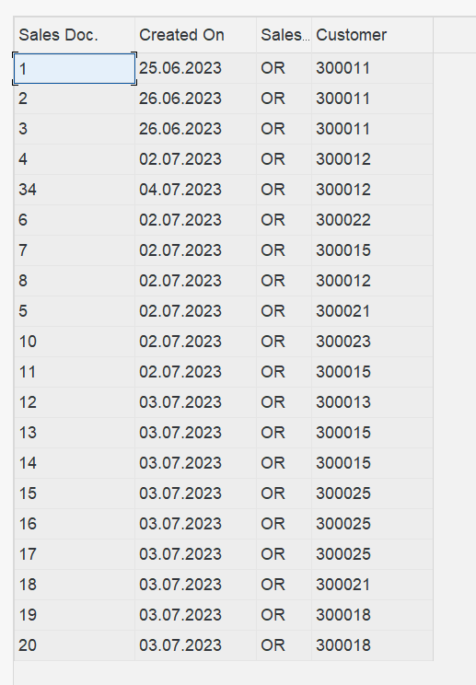

…………………………………………………………………………………***…………………………………………………………..  
**LAYOUTS**  
REPORT zrk_layouts.  
CLASS lcl_report DEFINITION.  
  
 PUBLIC SECTION.  
  
  
 TYPES: BEGIN OF ty_vbak,  
 vbeln TYPE vbak-vbeln,  
 erdat TYPE erdat,  
 auart TYPE auart,  
 kunnr TYPE kunnr,  
 END OF ty_vbak.  
  
 DATA: t_vbak TYPE STANDARD TABLE OF ty_vbak.  
  
  
 DATA: o_alv TYPE REF TO cl_salv_table.  
  
 METHODS:  
  
 get_data,  
  
  
 generate_output.  
  
 PRIVATE SECTION.  
  
 METHODS:  
 set_pf_status  
 CHANGING  
 co_alv TYPE REF TO cl_salv_table.  
*\**  
 METHODS:  
 set_layout  
 CHANGING  
 co_alv TYPE REF TO cl_salv_table.  
  
  
  
  
  
ENDCLASS.  
  
START-OF-SELECTION.  
 DATA: lo_report TYPE REF TO lcl_report.  
  
 CREATE OBJECT lo_report.  
  
 lo_report->get_data( ).  
  
 lo_report->generate_output( ).  
  
CLASS lcl_report IMPLEMENTATION.  
*\**  
 METHOD get_data.  
  
 SELECT vbeln erdat auart kunnr  
 INTO TABLE t_vbak  
 FROM vbak  
 UP TO 20 ROWS.  
  
 ENDMETHOD.  
  
 METHOD generate_output.  
  
 DATA: lx_msg TYPE REF TO cx_salv_msg.  
 TRY.  
 cl_salv_table=>factory(  
 IMPORTING  
 r_salv_table = o_alv  
 CHANGING  
 t_table = t_vbak ).  
 CATCH cx_salv_msg INTO lx_msg.  
 ENDTRY.  
  
  
 CALL METHOD set_pf_status  
 CHANGING  
 co_alv = o_alv.  
  
 CALL METHOD set_layout  
 CHANGING  
 co_alv = o_alv.  
  
 DATA: lo_functions TYPE REF TO cl_salv_functions_list.  
  
 lo_functions = o_alv->get_functions( ). *"--------added*  
 lo_functions->set_default( abap_true ).  
 o_alv->display( ).  
  
 ENDMETHOD.  
 METHOD set_pf_status.  
 co_alv->set_screen_status(  
 report = 'ZBABU_LAYOUT'  
 pfstatus = 'STANDARD'  
  
 ).  
 ENDMETHOD.  
 METHOD set_layout.  
  
 DATA: lo_layout TYPE REF TO cl_salv_layout,  
 lf_variant TYPE slis_vari,  
 ls_key TYPE salv_s_layout_key.  
  
 lo_layout = co_alv->get_layout( ).  
  
 ls_key-report = sy-repid.  
 lo_layout->set_key( ls_key ).  
  
 lo_layout->set_save_restriction( if_salv_c_layout=>restrict_none ).  
  
 lf_variant = 'DEFAULT'.  
 lo_layout->set_initial_layout( lf_variant ).  
  
  
  
 o_alv->display( ).  
  
  
 ENDMETHOD.  
ENDCLASS.

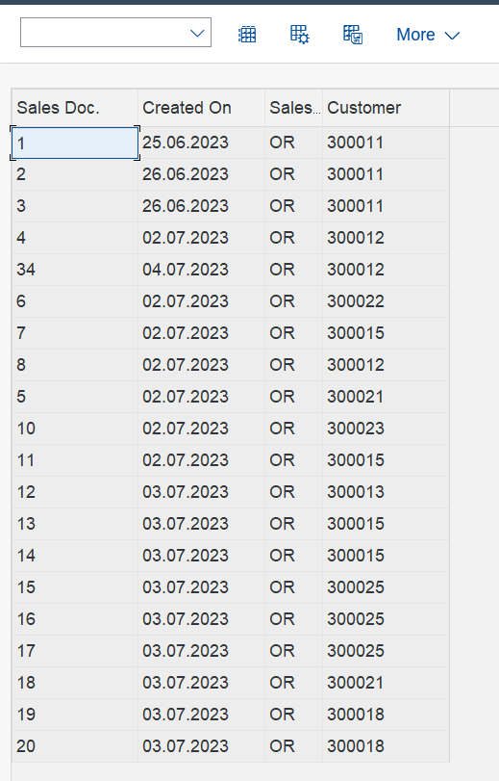

*…………………………………………………………………………***………………………………………………………………………*  
**SORT DECSENDING**

REPORT ZROHIT_DISPLAY.  
CLASS lcl_report DEFINITION.  
  
 PUBLIC SECTION.  
  
  
 TYPES: BEGIN OF ty_vbak,  
 vbeln TYPE vbak-vbeln,  
 erdat TYPE erdat,  
 auart TYPE auart,  
 kunnr TYPE kunnr,  
 END OF ty_vbak.  
  
 DATA: t_vbak TYPE STANDARD TABLE OF ty_vbak.  
  
  
 DATA: o_alv TYPE REF TO cl_salv_table.  
  
 METHODS:  
  
 get_data,  
  
  
 generate_output.  
  
 PRIVATE SECTION.  
  
 METHODS:  
 set_pf_status  
 CHANGING  
 co_alv TYPE REF TO cl_salv_table.  
*\**  
 METHODS:  
 set_layout  
 CHANGING  
 co_alv TYPE REF TO cl_salv_table.  
  
 METHODS:  
 set_top_of_page  
 CHANGING  
 co_alv TYPE REF TO cl_salv_table.  
 METHODS:  
 set_end_of_page  
 CHANGING  
 co_alv TYPE REF TO cl_salv_table.  
  
 METHODS:  
 set_display_setting  
 CHANGING  
 co_alv TYPE REF TO cl_salv_table.  
  
  
  
  
  
ENDCLASS.  
  
START-OF-SELECTION.  
 DATA: lo_report TYPE REF TO lcl_report.  
  
 CREATE OBJECT lo_report.  
  
 lo_report->get_data( ).  
  
 lo_report->generate_output( ).  
  
CLASS lcl_report IMPLEMENTATION.  
*\**  
 METHOD get_data.  
  
 SELECT vbeln erdat auart kunnr  
 INTO TABLE t_vbak  
 FROM vbak  
 UP TO 20 ROWS.  
  
 ENDMETHOD.  
  
 METHOD generate_output.  
  
 DATA: lx_msg TYPE REF TO cx_salv_msg.  
 TRY.  
 cl_salv_table=>factory(  
 IMPORTING  
 r_salv_table = o_alv  
 CHANGING  
 t_table = t_vbak ).  
 CATCH cx_salv_msg INTO lx_msg.  
 ENDTRY.  
  
 data: lc_sort type ref to cl_salv_sorts.  
 lc_sort = O_alv->get_sorts( ).  
 try.  
 lc_sort->add_sort( columnname = 'VBELN'  
 subtotal = abap_true  
 sequence = if_salv_c_sort=>sort_DOWN ).  
 catch: cx_salv_not_found cx_salv_data_error cx_salv_existing.  
 endtry.  
 CALL METHOD set_pf_status  
 CHANGING  
 co_alv = o_alv.  
  
 CALL METHOD set_layout  
 CHANGING  
 co_alv = o_alv.  
  
 CALL METHOD me->set_top_of_page  
 CHANGING  
 co_alv = o_alv.  
  
 CALL METHOD me->set_end_of_page  
 CHANGING  
 co_alv = o_alv.  
  
 CALL METHOD set_display_setting  
 CHANGING  
 co_alv = o_alv.  
  
 DATA: lo_functions TYPE REF TO cl_salv_functions_list.  
  
 lo_functions = o_alv->get_functions( ).  
 lo_functions->set_default( abap_true ).  
  
  
  
*\*write : /o_alv*  
  
 o_alv->display( ).  
  
*\* data: lc_sort type ref to cl_salv_sorts.*  
  
*\*lc_sort = O_alv->get_sorts( ).*  
*\**  
*\* try.*  
*\* lc_sort->add_sort( columnname = 'VBELN'*  
*\* subtotal = abap_true*  
*\* sequence = if_salv_c_sort=>sort_up ).*  
*\* catch: cx_salv_not_found cx_salv_data_error cx_salv_existing.*  
*\* endtry.*  
  
 ENDMETHOD.  
 METHOD set_pf_status.  
 co_alv->set_screen_status(  
 report = 'ZBABU_DISPLAY'  
 pfstatus = 'STANDARD'  
  
 ).  
 ENDMETHOD.  
 METHOD set_layout.  
  
 DATA: lo_layout TYPE REF TO cl_salv_layout,  
 lf_variant TYPE slis_vari,  
 ls_key TYPE salv_s_layout_key.  
  
 lo_layout = co_alv->get_layout( ).  
  
 ls_key-report = sy-repid.  
 lo_layout->set_key( ls_key ).  
  
 lo_layout->set_save_restriction( if_salv_c_layout=>restrict_none ).  
  
 lf_variant = 'DEFAULT'.  
 lo_layout->set_initial_layout( lf_variant ).  
  
  
 ENDMETHOD.  
 METHOD set_top_of_page.  
*\**  
 DATA: lo_header TYPE REF TO cl_salv_form_layout_grid,  
 lo_h_label TYPE REF TO cl_salv_form_label,  
 lo_h_flow TYPE REF TO cl_salv_form_layout_flow.  
*\**  
*\* header object*  
 CREATE OBJECT lo_header.  
*\**  
*\* To create a Lable or Flow we have to specify the target*  
*\* row and column number where we need to set up the output*  
*\* text.*  
*\**  
*\* information in Bold*  
 lo_h_label = lo_header->create_label( row = 1 column = 1 ).  
 lo_h_label->set_text( 'Header in Bold' ).  
*\**  
*\* information in tabular format*  
 lo_h_flow = lo_header->create_flow( row = 2 column = 1 ).  
 lo_h_flow->create_text( text = 'This is text of flow' ).  
*\**  
 lo_h_flow = lo_header->create_flow( row = 3 column = 1 ).  
 lo_h_flow->create_text( text = 'Number of Records in the output' ).  
*\**  
 lo_h_flow = lo_header->create_flow( row = 3 column = 2 ).  
 lo_h_flow->create_text( text = 20 ).  
*\**  
*\* set the top of list using the header for Online.*  
 co_alv->set_top_of_list( lo_header ).  
*\**  
*\* set the top of list using the header for Print.*  
 co_alv->set_top_of_list_print( lo_header ).  
*\**  
 ENDMETHOD. *"set_top_of_page*  
*\**  
 METHOD set_end_of_page.  
*\**  
 DATA: lo_footer TYPE REF TO cl_salv_form_layout_grid,  
 lo_f_label TYPE REF TO cl_salv_form_label,  
 lo_f_flow TYPE REF TO cl_salv_form_layout_flow.  
*\**  
*\* footer object*  
 CREATE OBJECT lo_footer.  
*\**  
*\* information in bold*  
 lo_f_label = lo_footer->create_label( row = 1 column = 1 ).  
 lo_f_label->set_text( 'Footer .. here it goes' ).  
*\**  
*\* tabular information*  
 lo_f_flow = lo_footer->create_flow( row = 2 column = 1 ).  
 lo_f_flow->create_text( text = 'This is text of flow in footer' ).  
*\**  
 lo_f_flow = lo_footer->create_flow( row = 3 column = 1 ).  
 lo_f_flow->create_text( text = 'Footer number' ).  
*\**  
 lo_f_flow = lo_footer->create_flow( row = 3 column = 2 ).  
 lo_f_flow->create_text( text = 1 ).  
*\**  
*\* Online footer*  
 co_alv->set_end_of_list( lo_footer ).  
*\**  
*\* Footer in print*  
 co_alv->set_end_of_list_print( lo_footer ).  
*\**  
  
 ENDMETHOD.  
 METHOD set_display_setting.  
*\**  
 DATA: lo_display TYPE REF TO cl_salv_display_settings.  
*\**  
*\* get display object*  
 lo_display = co_alv->get_display_settings( ).  
*\**  
*\* set ZEBRA pattern*  
 lo_display->set_striped_pattern( 'X' ).  
*\**  
*\* Title to ALV*  
 lo_display->set_list_header( 'ALV Test for Display Settings' ).  
*\**  
  
  
 o_alv->display( ).  
  
 ENDMETHOD.  
  
  
  
ENDCLASS.

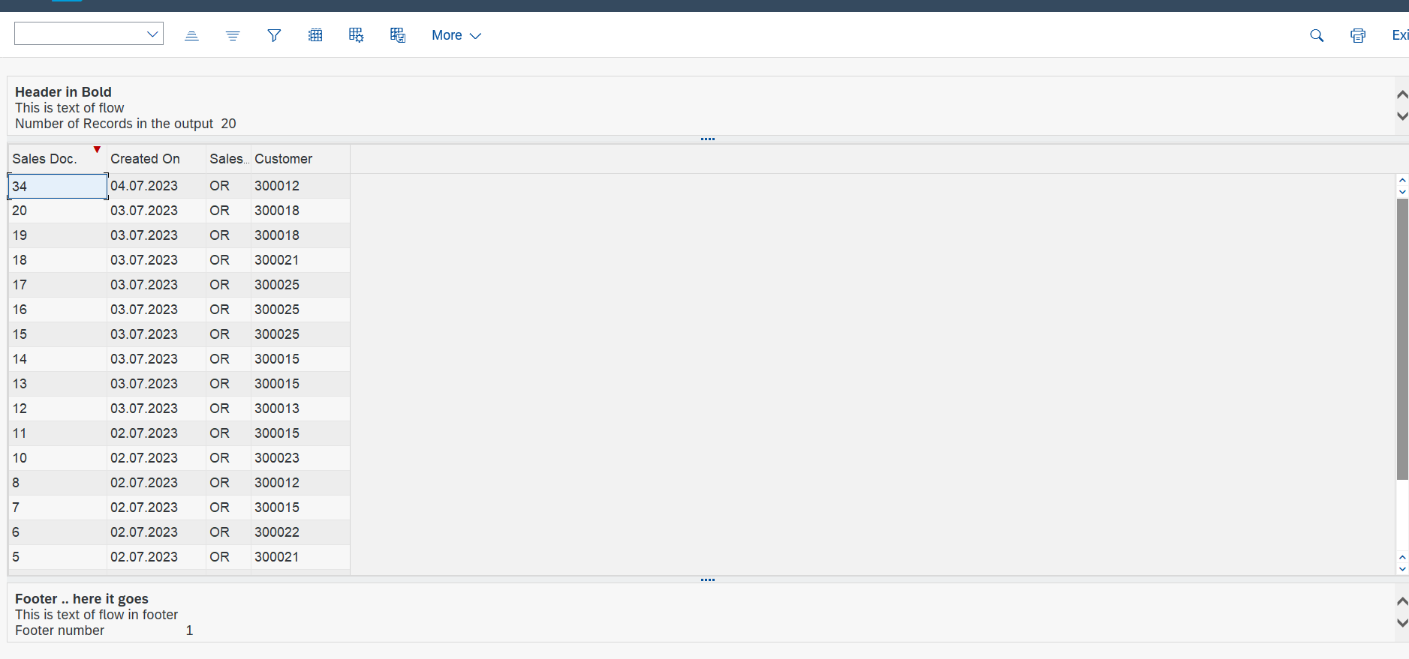

*……………………………………………………..***………………………………………………………………………………………**

**SORT ACSENDING**  
REPORT ZROHIT_DISPLAY.  
CLASS lcl_report DEFINITION.  
  
 PUBLIC SECTION.  
  
  
 TYPES: BEGIN OF ty_vbak,  
 vbeln TYPE vbak-vbeln,  
 erdat TYPE erdat,  
 auart TYPE auart,  
 kunnr TYPE kunnr,  
 END OF ty_vbak.  
  
 DATA: t_vbak TYPE STANDARD TABLE OF ty_vbak.  
  
  
 DATA: o_alv TYPE REF TO cl_salv_table.  
  
 METHODS:  
  
 get_data,  
  
  
 generate_output.  
  
 PRIVATE SECTION.  
  
 METHODS:  
 set_pf_status  
 CHANGING  
 co_alv TYPE REF TO cl_salv_table.  
*\**  
 METHODS:  
 set_layout  
 CHANGING  
 co_alv TYPE REF TO cl_salv_table.  
  
 METHODS:  
 set_top_of_page  
 CHANGING  
 co_alv TYPE REF TO cl_salv_table.  
 METHODS:  
 set_end_of_page  
 CHANGING  
 co_alv TYPE REF TO cl_salv_table.  
  
 METHODS:  
 set_display_setting  
 CHANGING  
 co_alv TYPE REF TO cl_salv_table.  
  
  
  
  
  
ENDCLASS.  
  
START-OF-SELECTION.  
 DATA: lo_report TYPE REF TO lcl_report.  
  
 CREATE OBJECT lo_report.  
  
 lo_report->get_data( ).  
  
 lo_report->generate_output( ).  
  
CLASS lcl_report IMPLEMENTATION.  
*\**  
 METHOD get_data.  
  
 SELECT vbeln erdat auart kunnr  
 INTO TABLE t_vbak  
 FROM vbak  
 UP TO 20 ROWS.  
  
 ENDMETHOD.  
  
 METHOD generate_output.  
  
 DATA: lx_msg TYPE REF TO cx_salv_msg.  
 TRY.  
 cl_salv_table=>factory(  
 IMPORTING  
 r_salv_table = o_alv  
 CHANGING  
 t_table = t_vbak ).  
 CATCH cx_salv_msg INTO lx_msg.  
 ENDTRY.  
  
 data: lc_sort type ref to cl_salv_sorts.  
 lc_sort = O_alv->get_sorts( ).  
 try.  
 lc_sort->add_sort( columnname = 'VBELN'  
 subtotal = abap_true  
 sequence = if_salv_c_sort=>sort_UP ).  
 catch: cx_salv_not_found cx_salv_data_error cx_salv_existing.  
 endtry.  
 CALL METHOD set_pf_status  
 CHANGING  
 co_alv = o_alv.  
  
 CALL METHOD set_layout  
 CHANGING  
 co_alv = o_alv.  
  
 CALL METHOD me->set_top_of_page  
 CHANGING  
 co_alv = o_alv.  
  
 CALL METHOD me->set_end_of_page  
 CHANGING  
 co_alv = o_alv.  
  
 CALL METHOD set_display_setting  
 CHANGING  
 co_alv = o_alv.  
  
 DATA: lo_functions TYPE REF TO cl_salv_functions_list.  
  
 lo_functions = o_alv->get_functions( ).  
 lo_functions->set_default( abap_true ).  
  
  
  
*\*write : /o_alv*  
  
 o_alv->display( ).  
  
*\* data: lc_sort type ref to cl_salv_sorts.*  
  
*\*lc_sort = O_alv->get_sorts( ).*  
*\**  
*\* try.*  
*\* lc_sort->add_sort( columnname = 'VBELN'*  
*\* subtotal = abap_true*  
*\* sequence = if_salv_c_sort=>sort_up ).*  
*\* catch: cx_salv_not_found cx_salv_data_error cx_salv_existing.*  
*\* endtry.*  
  
 ENDMETHOD.  
 METHOD set_pf_status.  
 co_alv->set_screen_status(  
 report = 'ZBABU_DISPLAY'  
 pfstatus = 'STANDARD'  
  
 ).  
 ENDMETHOD.  
 METHOD set_layout.  
  
 DATA: lo_layout TYPE REF TO cl_salv_layout,  
 lf_variant TYPE slis_vari,  
 ls_key TYPE salv_s_layout_key.  
  
 lo_layout = co_alv->get_layout( ).  
  
 ls_key-report = sy-repid.  
 lo_layout->set_key( ls_key ).  
  
 lo_layout->set_save_restriction( if_salv_c_layout=>restrict_none ).  
  
 lf_variant = 'DEFAULT'.  
 lo_layout->set_initial_layout( lf_variant ).  
  
  
 ENDMETHOD.  
 METHOD set_top_of_page.  
*\**  
 DATA: lo_header TYPE REF TO cl_salv_form_layout_grid,  
 lo_h_label TYPE REF TO cl_salv_form_label,  
 lo_h_flow TYPE REF TO cl_salv_form_layout_flow.  
*\**  
*\* header object*  
 CREATE OBJECT lo_header.  
*\**  
*\* To create a Lable or Flow we have to specify the target*  
*\* row and column number where we need to set up the output*  
*\* text.*  
*\**  
*\* information in Bold*  
 lo_h_label = lo_header->create_label( row = 1 column = 1 ).  
 lo_h_label->set_text( 'Header in Bold' ).  
*\**  
*\* information in tabular format*  
 lo_h_flow = lo_header->create_flow( row = 2 column = 1 ).  
 lo_h_flow->create_text( text = 'This is text of flow' ).  
*\**  
 lo_h_flow = lo_header->create_flow( row = 3 column = 1 ).  
 lo_h_flow->create_text( text = 'Number of Records in the output' ).  
*\**  
 lo_h_flow = lo_header->create_flow( row = 3 column = 2 ).  
 lo_h_flow->create_text( text = 20 ).  
*\**  
*\* set the top of list using the header for Online.*  
 co_alv->set_top_of_list( lo_header ).  
*\**  
*\* set the top of list using the header for Print.*  
 co_alv->set_top_of_list_print( lo_header ).  
*\**  
 ENDMETHOD. *"set_top_of_page*  
*\**  
 METHOD set_end_of_page.  
*\**  
 DATA: lo_footer TYPE REF TO cl_salv_form_layout_grid,  
 lo_f_label TYPE REF TO cl_salv_form_label,  
 lo_f_flow TYPE REF TO cl_salv_form_layout_flow.  
*\**  
*\* footer object*  
 CREATE OBJECT lo_footer.  
*\**  
*\* information in bold*  
 lo_f_label = lo_footer->create_label( row = 1 column = 1 ).  
 lo_f_label->set_text( 'Footer .. here it goes' ).  
*\**  
*\* tabular information*  
 lo_f_flow = lo_footer->create_flow( row = 2 column = 1 ).  
 lo_f_flow->create_text( text = 'This is text of flow in footer' ).  
*\**  
 lo_f_flow = lo_footer->create_flow( row = 3 column = 1 ).  
 lo_f_flow->create_text( text = 'Footer number' ).  
*\**  
 lo_f_flow = lo_footer->create_flow( row = 3 column = 2 ).  
 lo_f_flow->create_text( text = 1 ).  
*\**  
*\* Online footer*  
 co_alv->set_end_of_list( lo_footer ).  
*\**  
*\* Footer in print*  
 co_alv->set_end_of_list_print( lo_footer ).  
*\**  
  
 ENDMETHOD.  
 METHOD set_display_setting.  
*\**  
 DATA: lo_display TYPE REF TO cl_salv_display_settings.  
*\**  
*\* get display object*  
 lo_display = co_alv->get_display_settings( ).  
*\**  
*\* set ZEBRA pattern*  
 lo_display->set_striped_pattern( 'X' ).  
*\**  
*\* Title to ALV*  
 lo_display->set_list_header( 'ALV Test for Display Settings' ).  
*\**  
  
  
 o_alv->display( ).  
  
 ENDMETHOD.  
  
  
  
ENDCLASS.

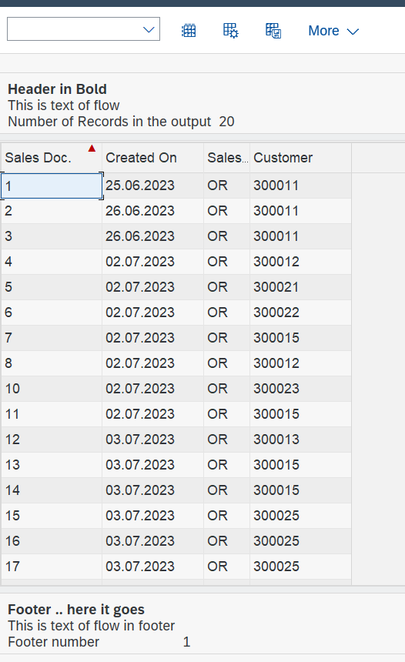

*…………………………………………………………………**…………………………………………………………………………………*

**COLOR**  
REPORT ZRK_ALV_COLOR.  
  
CLASS lcl_report DEFINITION.  
  
 PUBLIC SECTION.  
  
 TYPES: BEGIN OF ty_vbak,  
 vbeln TYPE vbak-vbeln,  
 erdat TYPE erdat,  
 auart TYPE auart,  
 kunnr TYPE kunnr,  
 t_color TYPE lvc_t_scol,  
 END OF ty_vbak.  
  
 DATA: t_vbak TYPE STANDARD TABLE OF ty_vbak.  
 TYPES: ty_t_vbak TYPE STANDARD TABLE OF ty_vbak.  
  
 DATA: o_alv TYPE REF TO cl_salv_table.  
  
 METHODS:  
 get_data,  
 generate_output.  
  
  
*\*private SECTION.*  
PRIVATE SECTION.  
METHODS:  
 set_pf_status  
 CHANGING  
 co_alv TYPE REF TO cl_salv_table.  
METHODS:  
 set_colors  
 CHANGING  
 co_alv TYPE REF TO cl_salv_table  
 ct_vbak TYPE ty_t_vbak.  
  
ENDCLASS.  
  
  
START-OF-SELECTION.  
 DATA: lo_report TYPE REF TO lcl_report.  
 *"DATA: o_alv TYPE REF TO cl_salv_table.*  
  
 CREATE OBJECT lo_report.  
  
 lo_report->get_data( ).  
  
 lo_report->generate_output( ).  
  
  
  
  
 CLASS lcl_report IMPLEMENTATION.  
  
  
  
  
 METHOD get_data.  
  
 SELECT vbeln erdat auart kunnr  
 INTO CORRESPONDING FIELDS OF TABLE t_vbak  
 FROM vbak  
 UP TO 20 ROWS.  
  
 ENDMETHOD.  
  
 METHOD generate_output.  
  
 DATA: lx_msg TYPE REF TO cx_salv_msg.  
 TRY.  
 cl_salv_table=>factory(  
 IMPORTING  
 r_salv_table = o_alv  
 CHANGING  
 t_table = t_vbak ).  
 CATCH cx_salv_msg INTO lx_msg.  
 ENDTRY.  
  
CALL METHOD set_pf_status  
 CHANGING  
 co_alv = o_alv.  
*\* Set the colors to ALV display*  
 CALL METHOD set_colors  
 CHANGING  
 co_alv = o_alv  
 ct_vbak = t_vbak.  
  
*\* Setting Default PFSTATUS USING SALV functions*  
DATA: lo_functions TYPE REF TO cl_salv_functions_list.  
  
 lo_functions = o_alv->get_functions( ).  
 lo_functions->set_default( abap_true ).  
 o_alv->display( ).  
  
 ENDMETHOD.  
  
 METHOD set_pf_status.  
*\*\**  
  
*\* Calling method to set the PF-Status*  
 co_alv->set_screen_status(  
 pfstatus = 'ZVJ2_ALV'  
 report = 'ZVJ_ALV_REPORT'  
 set_functions = co_alv->c_functions_all  
 ).  
*\*\**  
 ENDMETHOD.  
 METHOD set_colors.  
*\**  
*\*.....Color for COLUMN.....*  
 DATA: lo_cols_tab TYPE REF TO cl_salv_columns_table,  
 lo_col_tab TYPE REF TO cl_salv_column_table.  
 DATA: ls_color TYPE lvc_s_colo. *" Colors strucutre*  
*\**  
*\* get Columns object*  
 lo_cols_tab = co_alv->get_columns( ).  
*\**  
 INCLUDE <color>.  
*\**  
*\* Get ERDAT column & set the yellow Color fot it*  
 TRY.  
 lo_col_tab ?= lo_cols_tab->get_column( 'AUART' ).  
 ls_color-col = col_total.  
 lo_col_tab->set_color( ls_color ).  
 CATCH cx_salv_not_found.  
 ENDTRY.  
*\* Get ERDAT column & set the yellow Color fot it*  
 TRY.  
 lo_col_tab ?= lo_cols_tab->get_column( 'ERDAT' ).  
 ls_color-col = col_group.  
 lo_col_tab->set_color( ls_color ).  
 CATCH cx_salv_not_found.  
 ENDTRY.  
*\**  
*\*.......Color for Specific Cell & Rows.................*  
*\* Applying color on the 3rd Row and Column AUART*  
*\* Applying color on the Entire 5th Row*  
*\**  
 DATA: lt_s_color TYPE lvc_t_scol,  
 ls_s_color TYPE lvc_s_scol,  
 la_vbak LIKE LINE OF ct_vbak,  
 l_count TYPE i.  
*\**  
 LOOP AT ct_vbak INTO la_vbak.  
 l_count = l_count + 1.  
 CASE l_count.  
*\* Apply RED color to the AUART Cell of the 3rd Row*  
 WHEN 3.  
 ls_s_color-fname = 'AUART'.  
 ls_s_color-color-col = col_negative.  
 ls_s_color-color-int = 0.  
 ls_s_color-color-inv = 0.  
 APPEND ls_s_color TO lt_s_color.  
 CLEAR ls_s_color.  
*\**  
*\* Apply GREEN color to the entire row # 5*  
*\* For entire row, we don't pass the Fieldname*  
 WHEN 5.  
 ls_s_color-color-col = col_positive.  
 ls_s_color-color-int = 0.  
 ls_s_color-color-inv = 0.  
 APPEND ls_s_color TO lt_s_color.  
 CLEAR ls_s_color.  
  
 WHEN 10.  
 ls_s_color-color-col = col_group.  
 ls_s_color-color-int = 0.  
 ls_s_color-color-inv = 0.  
 APPEND ls_s_color TO lt_s_color.  
 CLEAR ls_s_color.  
 ENDCASE.  
*\*\* Modify that data back to the output table*  
 la_vbak-t_color = lt_s_color.  
 MODIFY ct_vbak FROM la_vbak.  
 CLEAR la_vbak.  
 CLEAR lt_s_color.  
 ENDLOOP.  
*\**  
*\* We will set this COLOR table field name of the internal table to*  
*\* COLUMNS tab reference for the specific colors*  
 TRY.  
 lo_cols_tab->set_color_column( 'T_COLOR' ).  
 CATCH cx_salv_data_error. *"#EC NO_HANDLER*  
 ENDTRY.  
*\**  
 ENDMETHOD. *"set_colors*  
 ENDCLASS.

